

DATA - ANALYSIS FOR CUSTOMER ACTIVATION & RETENTION

Submitted by:

**HARSHIL GORADIA**

**ACKNOWLEDGMENT**

This includes mentioning of all the references, research papers, data sources, professionals and other resources that helped you and guided you in completion of the project.

1. https://onlinelibrary.wiley.com
2. http://www.asmaindia.in/pdf/press/29-The-Impact-of-Utilitarian-and-Hedonic-Value-on-Online-Shopping-Behavior.pdf
3. https://www.geeksforgeeks.org
4. https://en.wikipedia.org/wiki/Wiki

**INTRODUCTION**

1. **What is Customer Retention?**

Customer retention refers to a company’s ability to turn customers into repeat buyers and prevent them from switching to a competitor. It indicates whether your product and the quality of your service please your existing customers. It’s also the lifeblood of most subscription-based companies and service providers. Customer retention strategies are the processes and initiatives businesses put in place to build customer loyalty and improve customer lifetime value.

1. **Why is customer retention important?**

Keeping your current customers happy is generally more cost-effective than acquiring first-time customers. According to the Harvard Business Review, acquiring a new customer can be 5 to 25 times more expensive than holding on to an existing one. You don’t need to spend big on marketing, advertising, or sales outreach. It is easier to turn existing customers into repeating ones, since they already trust your brand from previous purchases. New customers, however, often require more convincing when it comes to that initial sale. Customer loyalty won’t just give you repeat business. Loyal customers are more likely to give free recommendations to their colleagues, friends, and family. Creating that cycle of retained customers and buzz marketing is one way your company can cultivate customer loyalty for long-term success.

1. **Customer retention benefits:**

• Cost savings: Customer retention is generally more cost effective than acquiring first-time customers.

• Positive word of mouth marketing: Loyal customers are more likely to tell their friends and family about your brand.

• A better bottom line: Increasing retention rates by just 5 percent can increase revenue by 25 percent to 95 percent.

1. **E-Commerce websites and Customer Retention:**

For an e-commerce store, the customer retention rate is directly related to how much your customers trust you and how much they relish the experience of spending time on your website/app. Trust is built by being honest and upfront about the product and service. Questions like how you guarantee quality, what your process of customer service is, what the options for customer grievance redressal are and the like need to be answered upfront and put into practice. This builds trust and subsequently word of mouth. Coming to the experience that you create for your customers, aesthetics, ease of use and clarity are the three most important parameters. Aesthetics - A good looking vibrant user interface that functions smoothly without bugs is an absolute must. Do make sure it functions equally on all kinds of interfaces like laptop, tablet, mobile etc. Ease of use - Customers like to come back to e-commerce sites where they could view the product, compare options, read reviews and complete their transaction with minimum fuss and in the minimum time. Clarity - People love clarity when buying online. Clarity in terms of - how is my product going to be packed? How many days would it take for delivery? Is there a tracking mechanism? I may know there is a return policy if am not satisfied with it, but how does the return actually work? All these and more questions provide clarity to the buyer and enhance his experience manifold. Other than these, there can also be loyalty programs, tie-ups with other complimentary e-commerce providers and co-branded events with physical stores that will boost customer acquisition and retention. Tying up with a more known brand rubs off some of the reliability and trust onto us. That leads to further customer retention over a period of time.

1. **Review of Literature:**

Customer satisfaction has emerged as one of the most important factors that guarantee the success of online store; it has been posited as a key stimulant of purchase, repurchase intentions and customer loyalty. A comprehensive review of the literature, theories and models have been carried out to propose the models for customer activation and customer retention. Five major factors that contributed to the success of an ecommerce store have been identified as: service quality, system quality, information quality, trust and net benefit. The research furthermore investigated the factors that influence the online customers repeat purchase intention. The combination of both utilitarian value and hedonistic values are needed to affect the repeat purchase intention (loyalty) positively. The data is collected from the Indian online shoppers.

**Analytical Problem Framing**

Analytic problem framing involves translating the business problem into terms that can be addressed analytically via data and modelling. It’s at this stage that you work backwards from the results / outputs you want to the data/inputs you’re going to need, where you identify potential drivers and hypotheses to test, and where you nail down your assumptions. Analytic problem framing is the antithesis of merely working with the ready-to-hand data and seeing what comes of it, hoping for something insightful. Typically, the process moves on from here to data collection, cleansing and transformation, Methodology selection and model building, never to return. But if you’re willing to borrow and use a concept from complex adaptive systems – maps and models – you can make repeat use of this stage to improve your overall outcome.

1. **Hardware Requirements**

A mid-level computer that runs on Intel i3/i5/i7 or A10/A11/M1 or Ryzen 3/5 or any other equivalent chipset and a suitable processor.

1. **Software Requirements**

Windows / Linux /Mac OS

1. **Tools, Libraries and Packages used Tool:**

1.Anaconda Navigator

2. Jupyter Notebook

**Libraries and Packages:** 1. NumPy

2. Pandas

3. Matplotlib

4. Seaborn

1. **Data Pre- Processing**

For understanding the factors influencing the customer retention, we should consider 4 important variables.

These 4 variables manipulate the 'customer satisfaction', which in turn makes the customer to stay.

These variables are:

1. Hedonic Value.

2. Utilitarian Value.

3. Precieved Risk.

4. Customer Experience.

By Analysing based on these variables, we can find the basic factors influencing the 'customer satisfaction’. Thus, by achieving the 'customer satisfaction' we can make the customer to stay and make them buy more products.

So, we will do the following Analysis in 5 parts. We will use different parts of the given dataset to help us find the customer retention factors.

By following these processes, we can achieve a more efficient dataset. We will use Python through Jupyter notebook for data processing. Also, we will use Libraries such as Pandas, NumPy for Analysis and Matplotlib, seaborn for visualization.

1. **Exploratory Data-Analysis:**

* **Importing libraries in Jupyter Notebook.**

import pandas as pd

import numpy as np

import matplotlib.pyplot as plt

import seaborn as sns

import warnings

warnings.filterwarnings('ignore')

* **Importing dataset.**

df=pd.read_excel(r'C:\Users\Harshil Goradia\OneDrive\Desktop\customer_retention.xlsx')

* **Checking Null Values:**

df.isnull()

plt.figure(figsize=(20,16))

sns.heatmap(df.isnull())

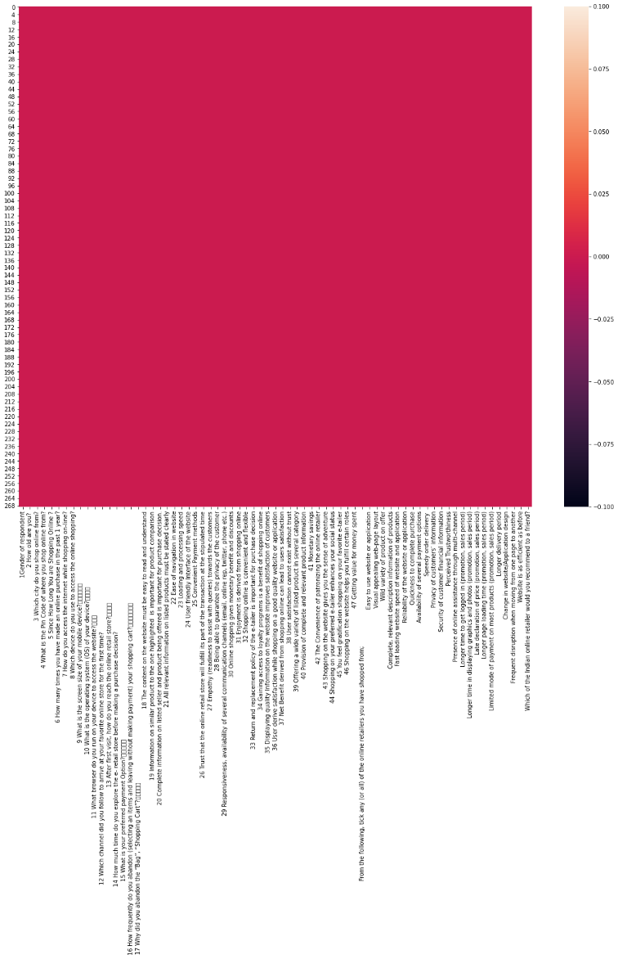

**Observation about the Data**

• The dataset seems to have 271 rows and 71 columns.

• The dataset does not have any Null values.

**We will divide the given dataset into 5 parts for the EDA:**

• Part-1 will be Customer Information.

• Part-2 will be Perceived Risk.

• Part-3 will be Utilitarian Value.

• Part-4 will be Hedonic Value.

• Part-5 will be Customer Experience.

**Visualizing percentage of male vs female in the dataset:**

x=df["1Gender of respondent"].value_counts()

print(x)

plt.figure(figsize=(5,5))

x.plot.pie(autopct='%1.1f%%', startangle=150, pctdistance=0.5, explode = (0.04,0.04),textprops={'fontsize': 12})

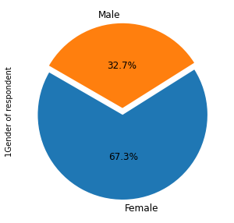

**We can observe that there are 32.7% Males and 67.3% Females in the data.**

**Visualizing Customer Information:**

for col in customer_info_:

print(df[col].value_counts())

plt.figure(figsize=(15,5))

sns.countplot(x=df[col],hue=df['1Gender of respondent'],palette='Blues')

plt.show()

print("\n \n")

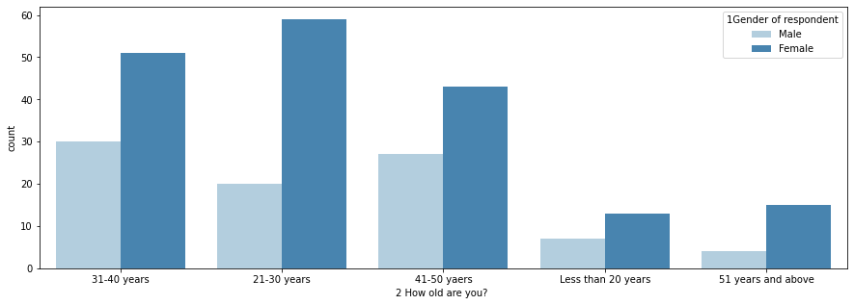 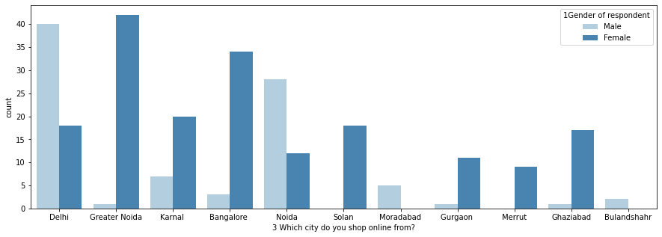

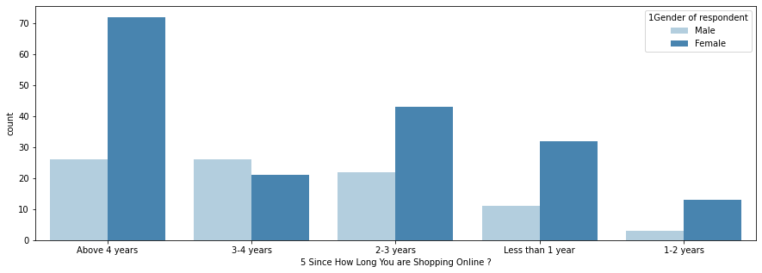

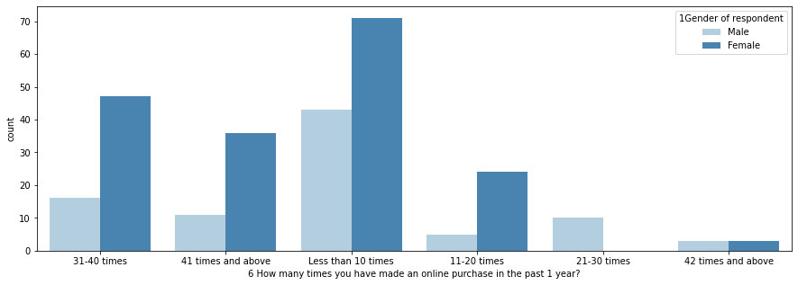

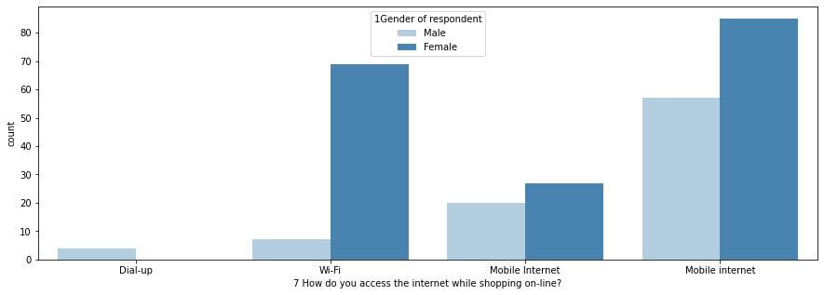

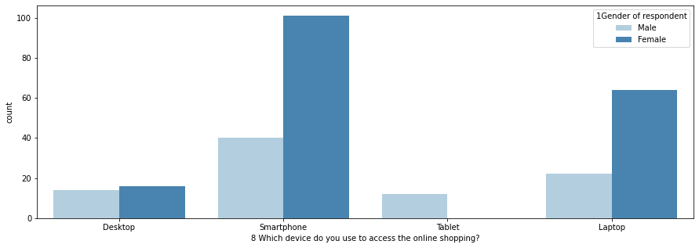

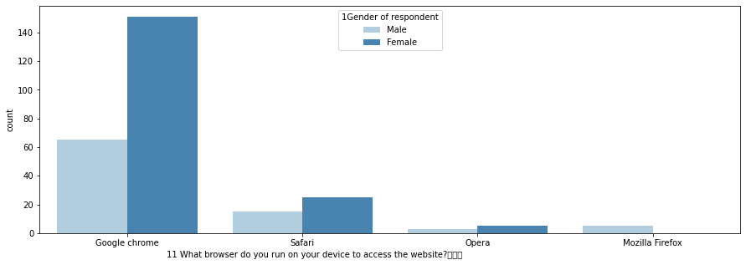

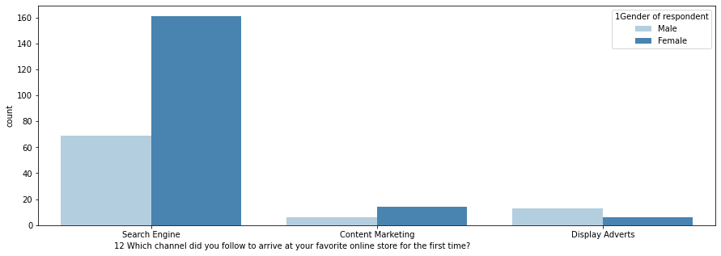

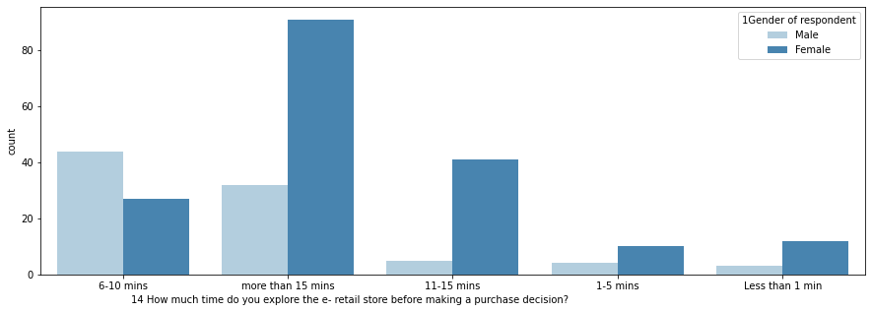

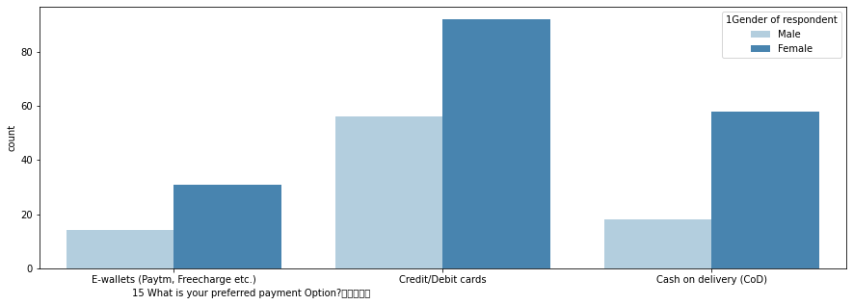

**OBSERVATIONS: CUSTOMER INFORMATION**

1. 80% (230 members) of the total participants are between the age group of 21-50 years, in which 21-30 years are 79 members(20 males and 59 females), 31-40 years are 81 members(30 males and 51 females) and 41-50 years are 70 members.
2. Participants from Delhi (40 males and 18 females), Noida (29 males and 11 females), Greater Noida (1 male and 42 females) and Bangalore (34 males and 3 females) seem to be shopping in higher range when considered to other cities included for the survey. This may be since many companies and colleges are around this area.
3. 36.43% customers are using E-commerce for more than 4 years. Only 17.47% customers are using for 3-4 years whereas 24.16% customers have been using e-commerce for 2-3 years. Percentage of customers who have been using e-commerce for less than 2 years is around 21.93.
4. Only 6 (3 each male and females) have done shopping 42 times or more. Most number of people have shopped less than 10 times i.e., 114 (72 females and 42 males). 63 people have done shopping between 31-40 times. People you have done shopping for 21-30 times consist of 10 males.
5. Most of the customers seem to be using Smart Phone (141) and Mobile Internet (142) for shopping. This means the E-commerce website should be compatible in all kinds of smart phone browsers to attract a lot more customers.
6. Around 80% customers use Google Chrome browser to use websites. Many used search engine to find their favourite online store, which means the E-commerce website should be search engine optimized on all times.
7. Also, after the search engine, E-commerce application seems to be the second favourite mode of logging in to the website. This means the application should be user friendly and UI should be more convenient for users.
8. Around 100 females and 23 males spend 15 mins before making purchase decision. 71 customers spend 6-11 mins before making a decision whereas less than 30 people decide in less than 5 minutes.
9. 54.27% customers desire to pay via Credit/ Debit cards while shopping online, we can assume looking at this data that people have built more trust for such websites as to last decade. Only 76 out of 269 go for Cash On Delivery option.

**Visualizing Perceived Risk:**

for col in Percieved_Risk:

print(df[col].value_counts())

plt.figure(figsize=(10,5))

sns.countplot(x=df[col],palette="Blues")

plt.show()

print("\n \n")

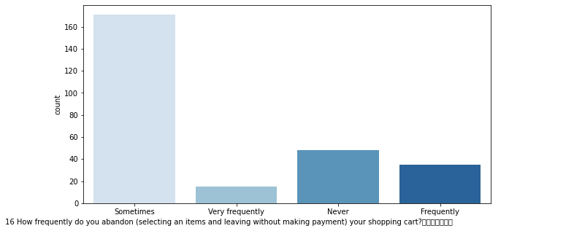 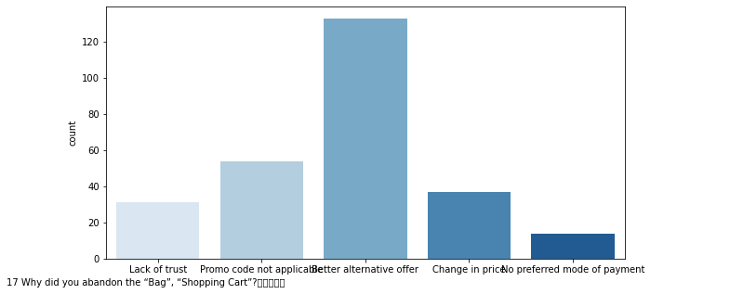

# OBSERVATIONS: PERCIEVED RISK

1. Out of 269, 171 people abandon the cart sometimes but 48 of them never do that. 35 abandon the cart frequently.
2. The reason observed why people abandon the cart is because they find better alternative offer. Second most common reason is promo code not applicable which hurts the customer, and they abandon the cart. 'Change in prices' and 'Lack of trust' are also other reasons why people abandon the cart. Very few people abandon the cart as they couldn't their preferred mode of payment.

**Visualizing Utilitarian Value:**

for col in Utilitarian:

print(df[col].value_counts())

plt.figure(figsize=(15,5))

sns.countplot(x=df[col],palette="Blues")

plt.show()

print("\n \n")

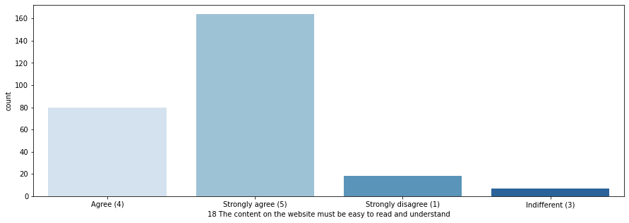



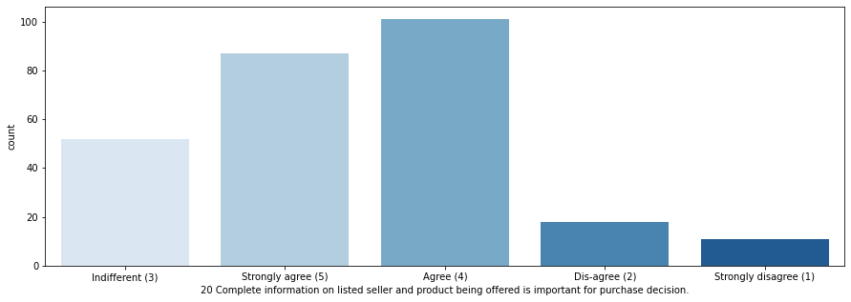

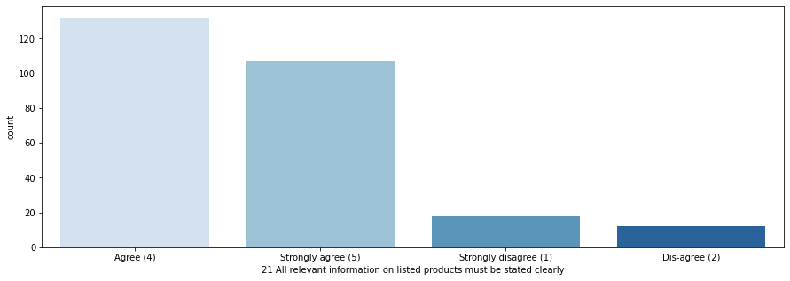

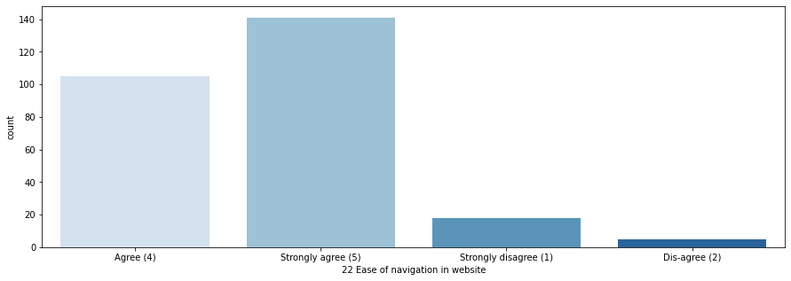

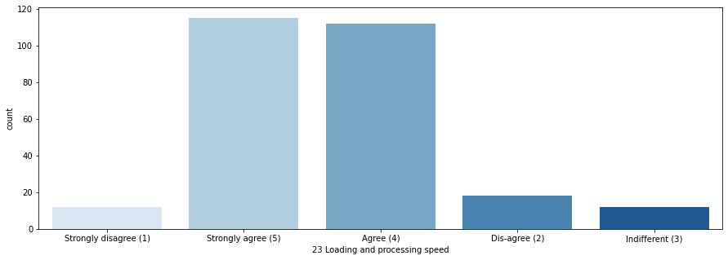

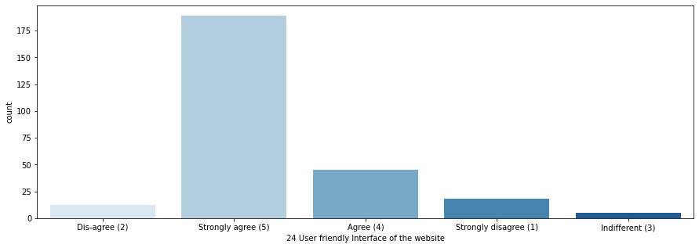

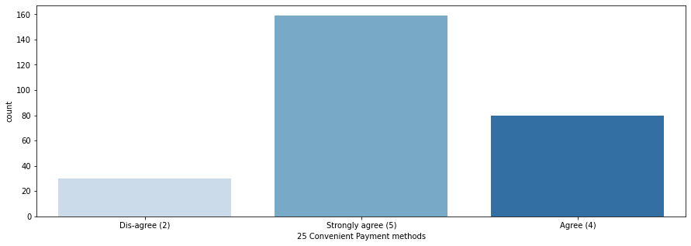

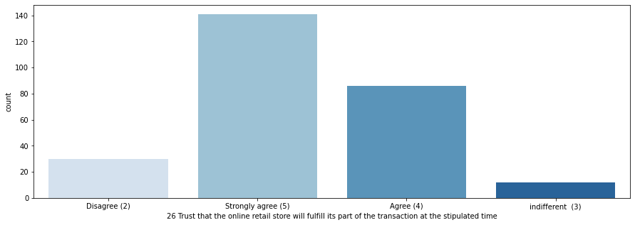



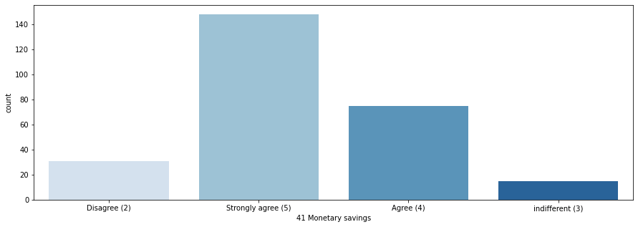

# OBSERVATIONS: UTILITARIAN VALUE

1. Most of the participants strongly agree that the content on the website must be easy to read and understand. Some of them just agree that the content should be easy to read and understand. Some of them strongly disagree.
2. Around 74% of the total customer strongly agrees or just agree that the information on similar product to the one highlighted is important for product comparison. Rest do not think similar products should be highlighted.
3. Most of the participants agree with the fact that provision of complete information on listed seller and product being offered is important for purchase decision. 52 people think its indifferent as the details. Rest do not think it is important.
4. Most of the customers expect that all relevant information on listed products must be stated clearly. Only 30 do not want relevant and clear information for the listed item.
5. Nearly 90% of the customer expects a user-friendly interface of the website along with ease of navigation; also they want the loading and processing speed to be less.
6. Most customers want many options for payment methods so that they can choose which is convenient them individually and also most of them trust online retail stores to complete payments at the stipulated time.
7. Most people expect the E-commerce website to have empathy towards its customers so that if they are stuck anywhere, CSR can assist them.
8. All the customers expect a guaranteed privacy.
9. 240 customers choose online shopping because of the monetary benefit and discounts.
10. Also many enjoy the process of online shopping as they find it convenient and flexible.
11. Most customers strongly agree that return and replacement policy of the product is important for purchase decision.
12. If quality information is displayed more customer satisfaction is gained, as per the survey.
13. Apart from 8 customers rest all agree that users derive satisfaction while shopping on a good quality website or application. Also almost every of them think building trust is most import for customer satisfaction.
14. Around 80% of the participants choose online shopping because of the wide range of category on products.
15. 31 people disagree that there is no money saving on online retails stores rest all agree or strongly agree that they save money while shopping online.

**Visualizing Hedonic Value:**

for col in Hedonic:

print(df[col].value_counts())

plt.figure(figsize=(15,5))

sns.countplot(x=df[col],palette="Blues")

plt.show()

print("\n \n")

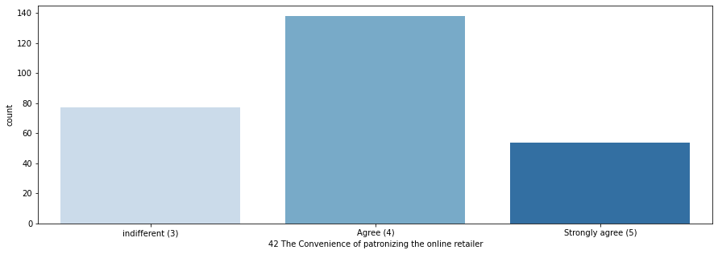

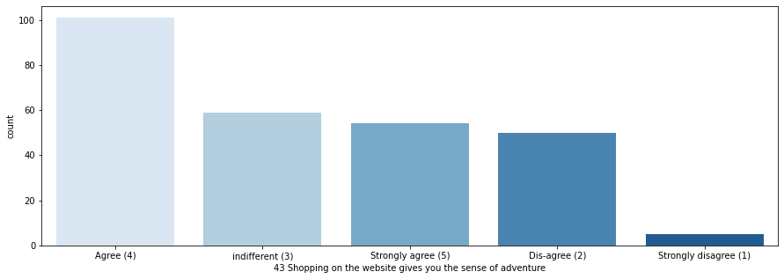

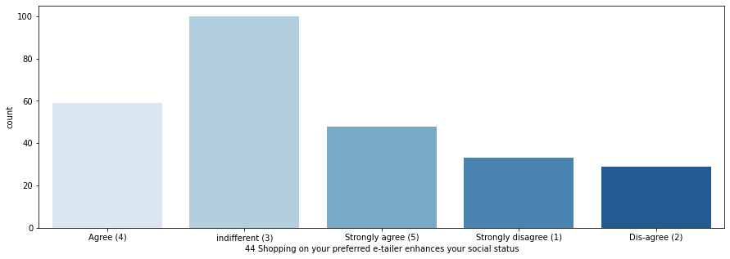



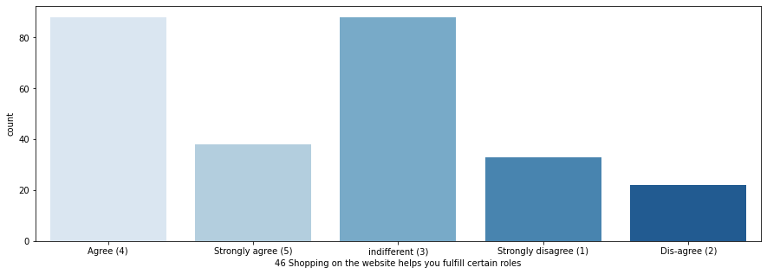

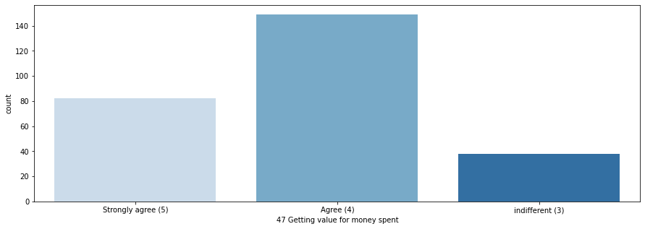

# OBSERVATIONS: HEDONIC VALUE

1. Many consumers agree that they like the convenience of patronizing the online retailer. Few do not find patronizing convenient.
2. More than 3/4 customers doing online shopping accept that they receive sense of adventure while shopping online.
3. Many customers don’t agree that shopping on their preferred website enhances their social status.
4. Half of the total participants say that shopping on the website helps them fulfil certain roles and give them gratification shopping from their favourite e-tailer.
5. 85-88% of the customer agrees that they are getting value for money spent while shopping online.

**Visualizing Customer Experience:**

for col in Customer_Experience:

print(df[col].value_counts())

plt.figure(figsize=(15,5))

sns.countplot(x=df[col],palette="Blues")

plt.xticks(rotation=90)

plt.show()

print("\n \n")

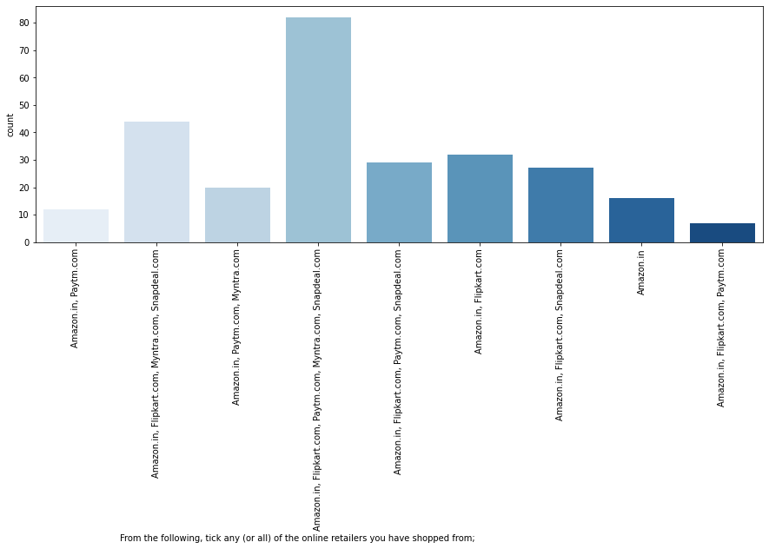

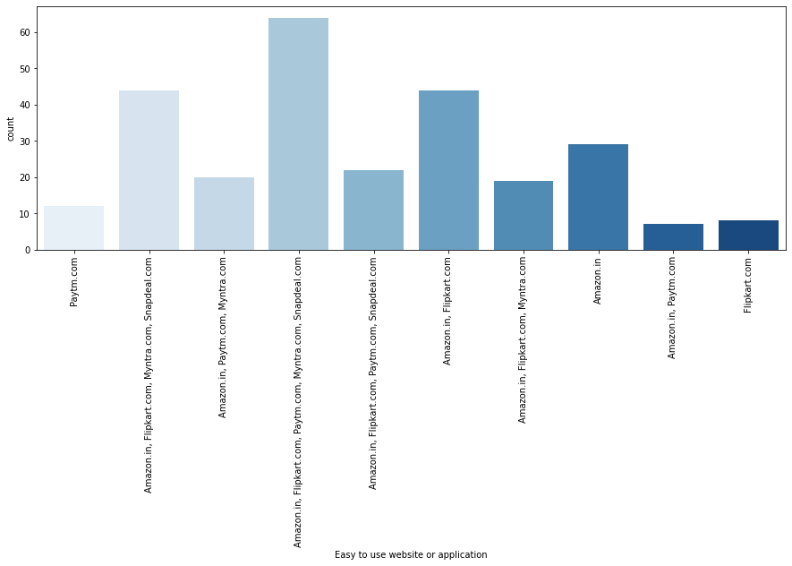

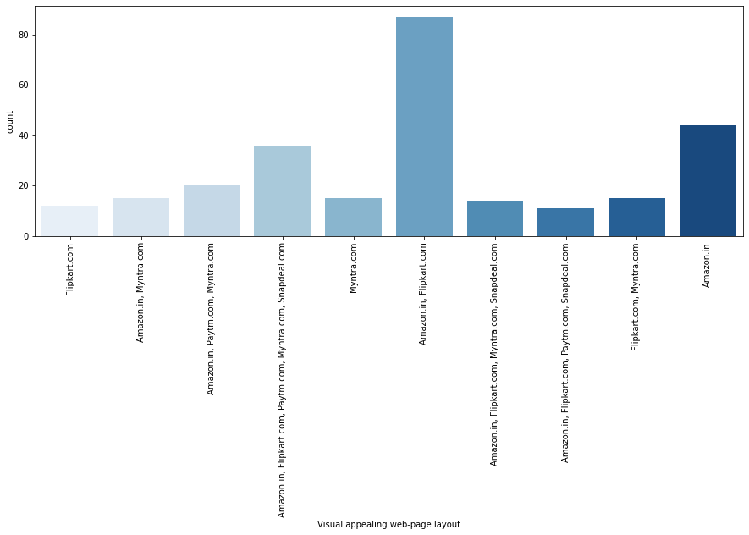



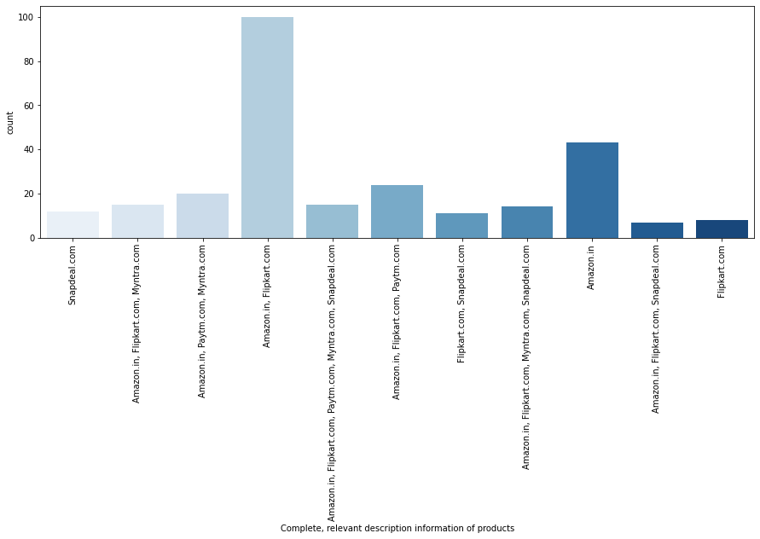

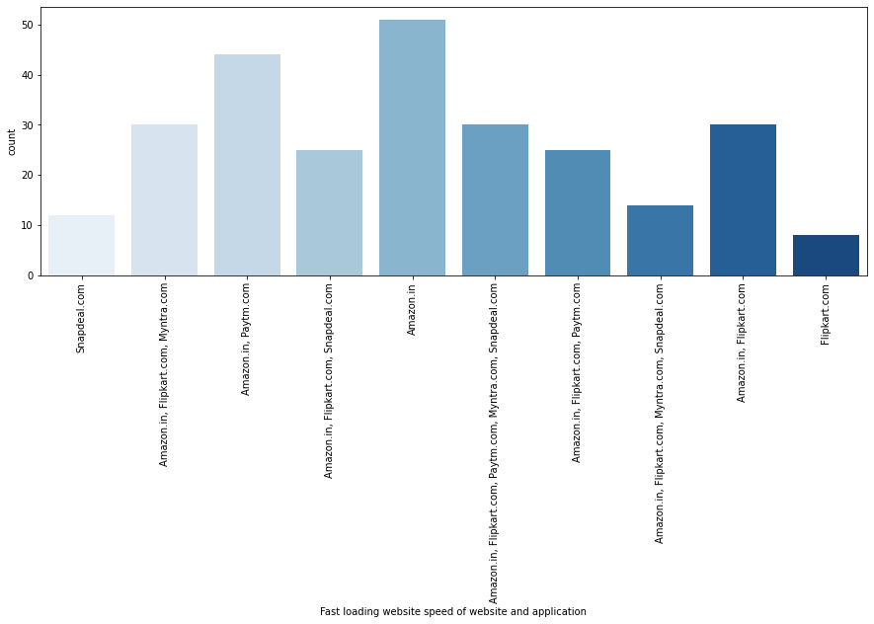



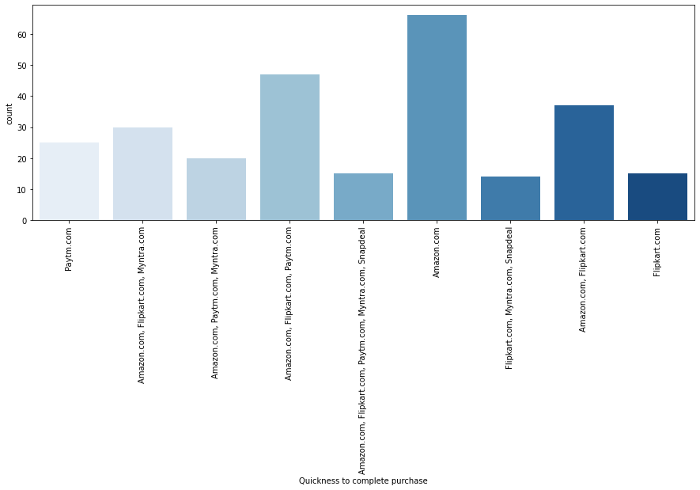

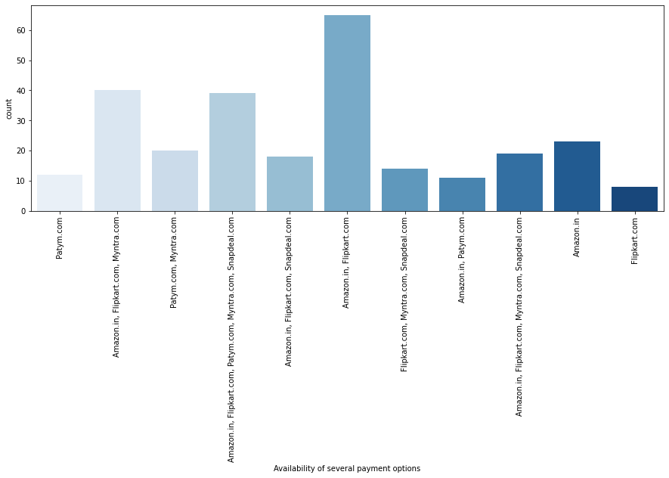

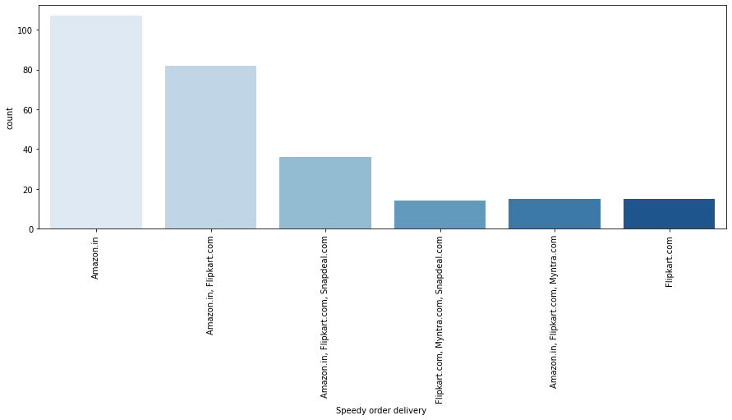

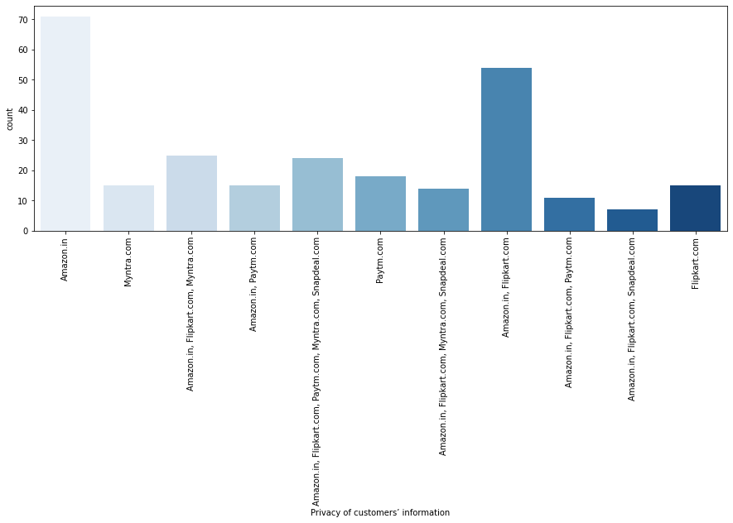

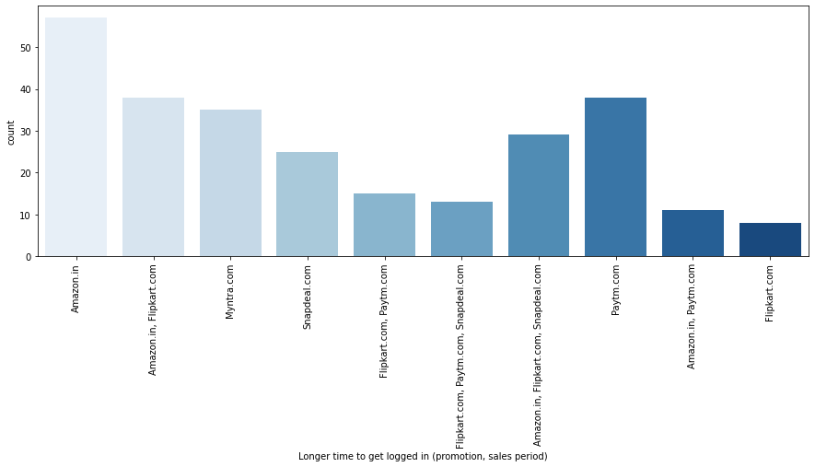

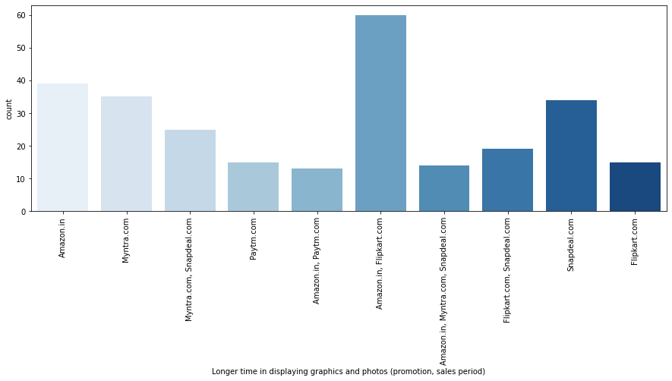

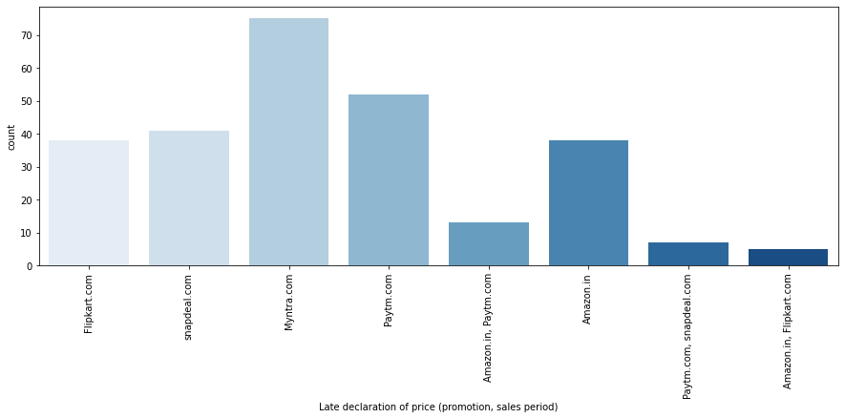

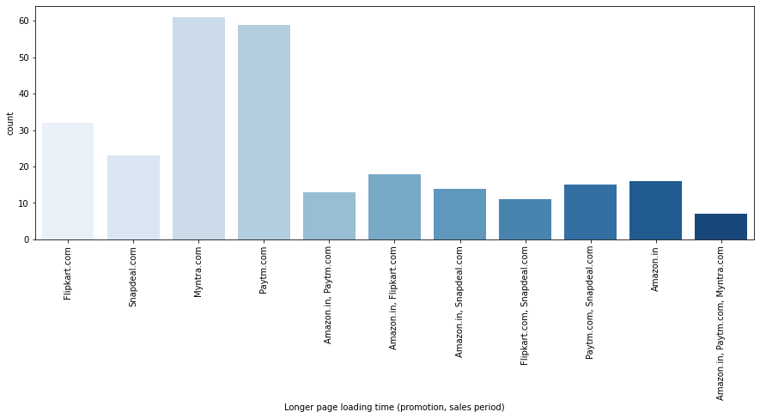





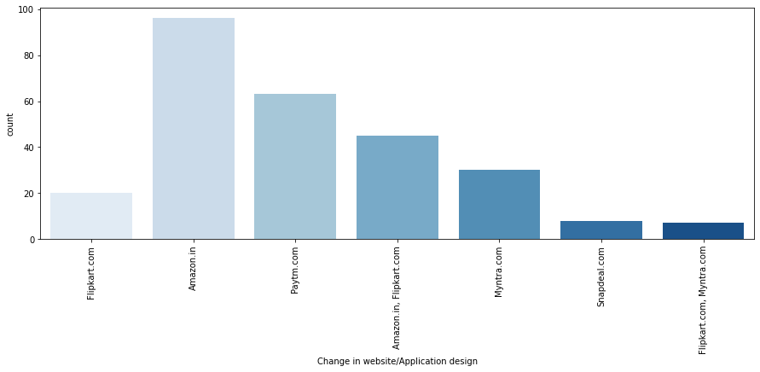

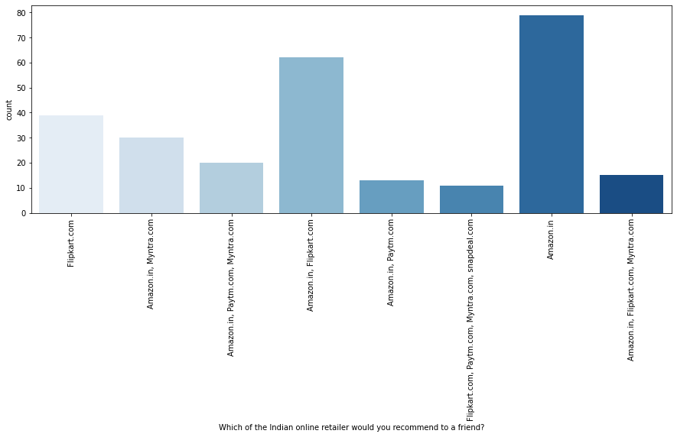

# OBSERVATION: CUSTOMER EXPERIENCE

1. Most of the customers shopping online have shopped majorly from the following websites, Amazon. In, Flipkart.com, Snapdeal.com, paytm.com.
2. Amazon, flipkart, snapdeal, myntra seems to have easy to use website or application.
3. Amazon.in and Flipkart.com has a visually appealing web-page layout.
4. Amazon.in and Flipkart.com has a wild variety of products on offers.
5. Amazon.in and Flipkart.com has complete and relevant description information of products compared to all other websites.
6. Amazon. In, Flipkart.com, Snapdeal.com, paytm.com, myntra.com has fast loading websites.
7. Amazon.in and Flipkart.com has the reliability of the customer.
8. Amazon.in, Flipkart.com has quickness towards completing the purchase.
9. Amazon. In, Flipkart.com, Snapdeal.com has availability of several payment options.
10. Amazon.in and Flipkart.com has speedy order delivery.
11. According to customers the privacy and security of customer financial information is maintained by Amazon.in and Flipkart.com.
12. Amazon. In, Flipkart.com, Snapdeal.com has a Perceived Trustworthiness.
13. Presence of online assistance through multi-channel is mostly provided by Amazon.In, Flipkart.com, and Snapdeal.com.
14. Longer time to get logged in (promotion, sales period): Amazon.in, Flipkart.com, Paytm.com.
15. Amazon.in, Flipkart.com, Myntra.com, Snapdeal.com takes longer time in displaying graphics and photos.
16. Myntra.com, Paytm.com, snapdeal.com has a practice of late declaration of prices.
17. Myntra.com, Paytm.com, snapdeal.com, Flipkart.com has a longer page loading time (promotion, sales period).
18. Amazon.in and snapdeal.com has limited mode of payment on most products.
19. Paytm.com, snapdeal.com, Flipkart.com has a longer delivery period.
20. Amazon.in, Paytm.com has regular change in website/application design.
21. Amazon.in, Myntra.com, Snapdeal.com, Paytm.com has frequent disruption when moving from one page to another.
22. Amazon.in and Flipkart.com Website are as efficient as before.
23. Amazon.in and Flipkart.com seems to be the most recommended Indian online retailer website.

# CONCLUSION:

The purpose of this study is to understand the influence of utilitarian values, hedonic values, customer experience and perceived risk on E-commerce customer satisfaction in India.

According to the analysis above we can conclude that customer satisfaction is the important factor for customer retention and gaining new customers. We divided the dataset into different parts to understand Consumer Behaviour. Utilitarian value is proposed as a formative second-order construct formed by product offerings, product information, monetary savings and convenience. Hedonic value is also proposed as a formative second-order construct formed by adventure shopping, social shopping, gratification, idea, role and value shopping.The results indicate that both the utilitarian value and hedonic value are positively associated with buyers' intention to repeat purchases and recommend others. Both utilitarian value and hedonic value have a high amount of effect on customer satisfaction and customer retention which means higher the utilitarian and hedonic value the higher the customer satisfaction is achieved and vice versa.

On the basis of these factors we could see that,

1. **Amazon.in**
2. **Flipkart.com**

**Both have done amazing job all-round to meet customer satisfaction and customer retention**.

THANK YOU